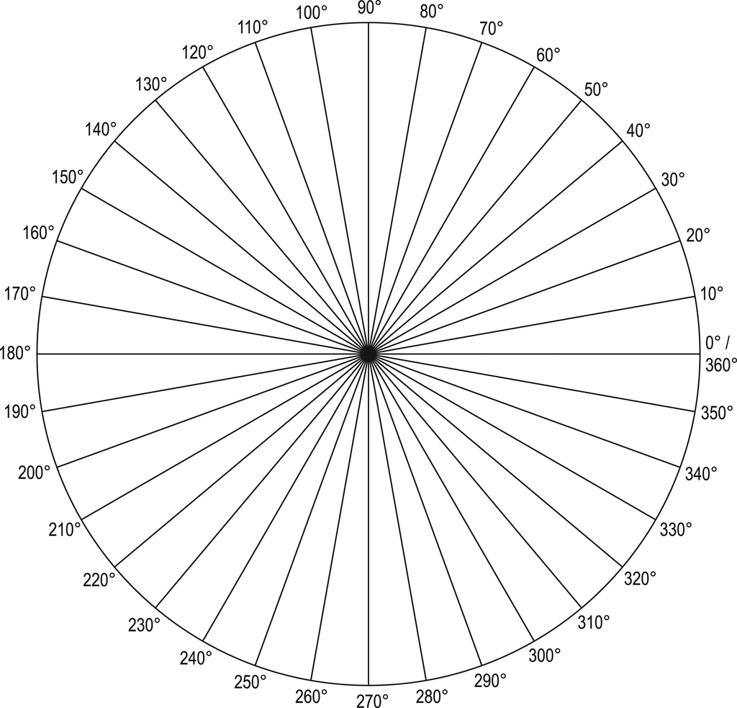

COMPASS CALIBRATION AND VALIDATION